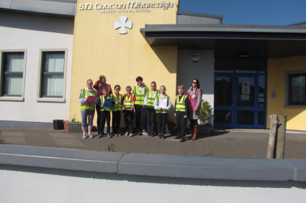
Walkability Audit
27th March 2019
Roll Number:
07518E
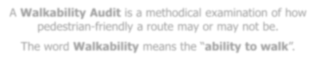
Melview NS County Longford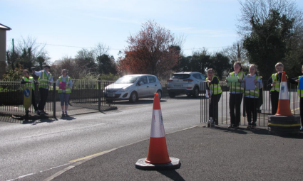
A Walkability Audit is a methodical examination of how pedestrian-friendly a route may or may not be.
The word Walkability means the “ability to walk”.
Members of the school population identified a possible walking route to school to audit.
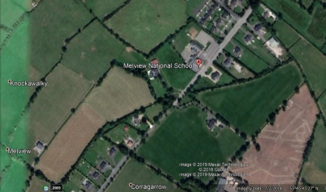
Objectives:
1. To identify good things and bad things on one of our walking routes
2. How to make our identified route safer
We used a number of tools on the audit to record our findings:
• Recording sheets
• Recording devices
• Hi-visibilty vests
• Camera
• Pencils/Clipboards
• Measuring tape
•Speed gun
Description of the route audited:
From the School Gates we turned right towards Clonbalt We walked beyond the 50kph road sign to nearby houses which are set back from the road. This is a route that has no footpath.
We noted the following findings from our Walkability Audit:
1. We found driver behaviour to be most alarming with speeds of up to 81, 89kph and 92kphin the 50 kph zone recorded. 2. The footpath outside the school was smooth and even 3. A crossing point with barriers is outside the school (this is not a pedestrian crossing)
4. Faded ‘No Parking’ lines, fades ‘Bus Parking’ lines 5. Space for buses is limited
6. The Slow sign on the road is very very faded 7. Road markings in general are very faded
8. The road signs are very dirty with algae growth 9. The lights on the School ahead sign does not function – the sign is also cracked (struck by a large vehicle perhaps) 10. There are no footpaths beyond the school to the houses nearby
11. The 50 kph sign is located oddly close to the school – the lead in time is completely insufficient – perhaps out of sync with guidelines
12. In the 80 kph zone (which should be 50kph) there is no grass verge – a local child jumps onto the bank to avoid traffic
13. This student took part in the audit described how he now goes to school ‘earlier’ or ‘later’ to avoid the traffic – due to the lack of grass verge/footpath
More details and photos of these findings can be viewed in the pages following.
We noted the following findings from our Walkability Audit:
14. In 35 minutes 58 cars and 7 vans were recorded – a total of 65 motorised vehicles in 35 minutes.
15. Students cycle to the school including one student who makes the trip each day from Clonbalt.
16. No traffic calming measures were noted during the audit 17. No Cyclists on road signs were noted
18. Drivers were also noted using their mobile phones whilst driving past the school
19. We spoke with locals and heard of one woman who no longer walks this road due to driver speed and behaviour and portions where there is nowhere to stand in.
More details and photos of these findings can be viewed in the pages following.
A summary of our recommendations is below:
1. Due to excessive speeds on this stretch of road – serious consideration to be given to the installation of a periodic 30 kph speed limit
2. Until such time introduce traffic calming with use of road markings
3. Move the current 50kph sign further back
4. Maintenance of current signs
5. Road and carparking markings in general to be updated 6. Convert current Crossing point to a Pedestrian crossing - reconsider barrier layout
7. Explore substantive traffic calming to reduce the ‘runway effect’ of this straight stretch – especially in blind sopts either side of the brow of the hill
8. Consider extension of footpath and in so doing eliminate dangerous zone where there is no grass verge/only high grass bank
9. Put up a series of Cyclist signs as the road is regularly used by young cyclists
Signage has become dirty over time
Ask maintenance crew to clean
Signage dirty – crack also noted. Lights not
working
Ask maintenance crew to clean and repair/replace and check lights
Repaint and reword the No exit
Footpath is good – great if it
point of the carpark
could be extended
change to an arrow
Repaint and perhaps change No
Repaint the yellow square
Entry to arrows in/out
The 50kph sign could be moved back down the road to
around here
Cycling to school would increase if the road was made safer
Crossing point at School – Could this be converted to a pedestrian crossing?
Periodic speed limit signs similar to many pairs in County Laois would be most welcome at this school and the local area in general
Speeding was common in the two observation
periods – the highest
being 92kph in a 50 zone
Introduce traffic calming measures, road markings AND consider the
installation of a periodic 30kph zone
This 50kph sign is almost at the school perimeter – located much too close
Move further down the road and in addition add road markings to encourage speed reduction
A safer position – however between here and the
school – walking is
treacherous as there is no grass verge only two
grassy banks
Consider a footpath
extension from the
current one at the school
Long straight stretch of road on both approaches to the school – leading to a speeding culture
Periodic 30kph signs and traffic calming would be very welcome
Love 30
Description of the route audited:
1. As a Green-School we support the Love 30 Campaign which calls on all Local Authorities to introduce more 30km/h zones in urban areas, but particularly in town centres, residential estates, in the vicinity of schools and in places of public assembly.
2. The Green-Schools Committee feel that driver feedback signs will make a difference to the speed at which vehicles travel outside their school. However! To make the road even safer and pedestrian friendly, lowering the speed limit to 30km/h would have the biggest impact.
Thank you for reading our report.
Please contact us with your feedback using the details below.
Green-Schools Travel Education Officer
Lorraine Flanagan
Email: Phone:
lflanagan@eeu.antaisce.org 087 2823728
School Details:
Name: School:
Email: Phone:
Mary O’Boyle Principal Melview NS
Melview
County Longford
melviewschool@gmail.com 043 3346197

