Mary’s Story about Periods

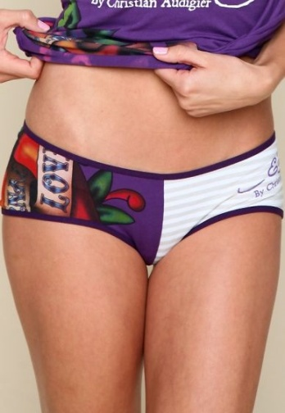

Once I was a baby.

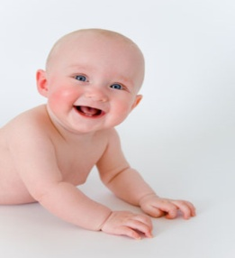

Then I was a little girl.

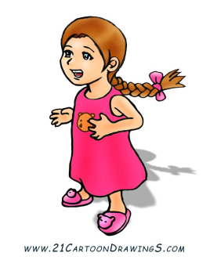

Now I am a big girl



and soon I will be a woman.

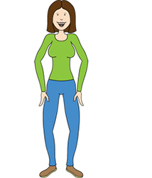

When I am a woman blood will come from my vagina which is between my legs.

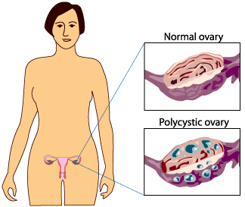

The blood flow will happen about once a month and will last about 5 days.

[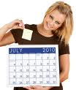](http://www.google.ie/imgres?imgurl=http://www.womansday.com/var/ezflow_site/storage/images/wd2/content/health/understanding-your-menstrual-cycle/970129-1-eng-US/Understanding-Your-Menstrual-Cycle_full_article_vertical.jpg&imgrefurl=http://www.womansday.com/Articles/Health/Understanding-Your-Menstrual-Cycle.html&usg=__q-BVe6MaLZgaedp7guLro2cNufc=&h=384&w=324&sz=25&hl=en&start=13&zoom=1&tbnid=E0E3vLW4jgseTM:&tbnh=123&tbnw=104&prev=/images?q=woman%27s+bottom-+menstruation&um=1&hl=en&safe=vss&sa=N&rlz=1T4DBIE_enIE310IE301&tbs=isch:1&um=1&itbs=1)

I will need to wear a sanitary pad

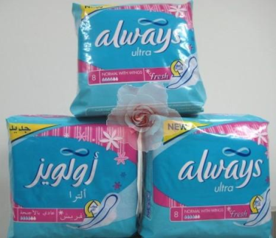 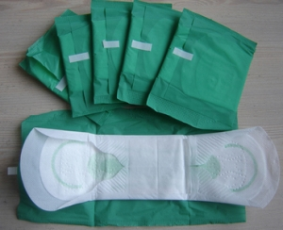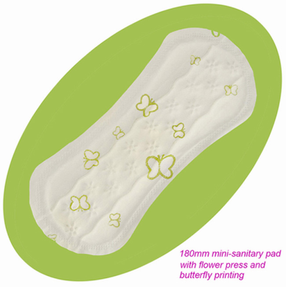

inside my pants

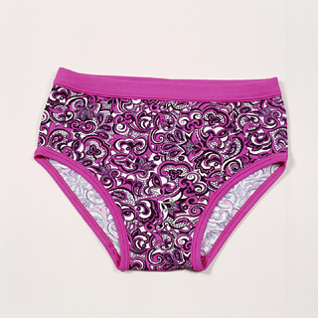

so that blood does not get on my clothes.

When I go to the toilet I will put the used pad

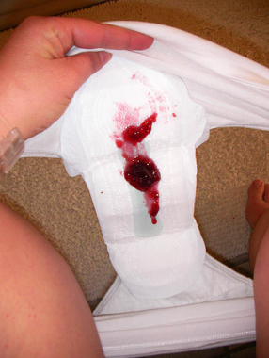 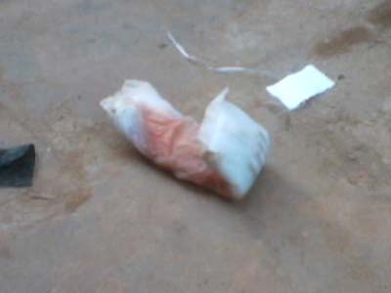

in a plastic bag

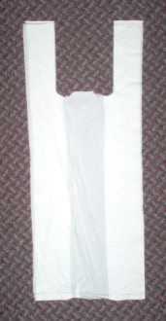 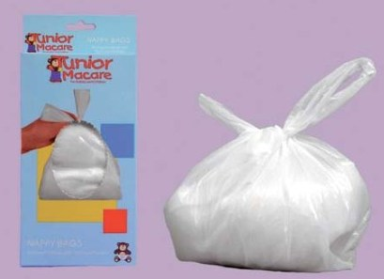

and put it in the bin.

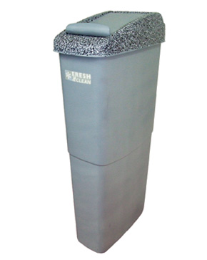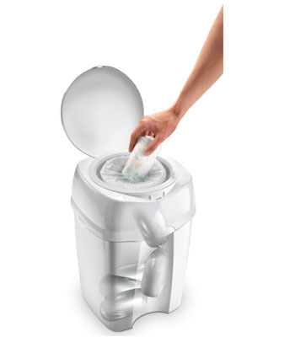

I will put a new



pad in my pants.

[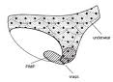](http://www.google.ie/imgres?imgurl=http://partypantspads.com/files/cache/underwear_diagram.jpg&imgrefurl=http://partypantspads.com/faq&usg=__WHaMNAYrlOXcVwtKbJot8T7EkXM=&h=227&w=314&sz=17&hl=en&start=49&zoom=1&tbnid=Mz4vsNOMix1FHM:&tbnh=85&tbnw=117&prev=/images?q=putting+pad+in+panties&start=40&hl=en&safe=vss&sa=N&gbv=2&tbs=isch:1&itbs=1)

When I have my period it is important that I wash between my legs 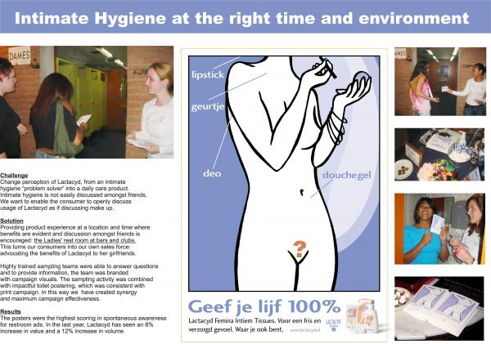

every day.

I will want to feel fresh and clean.

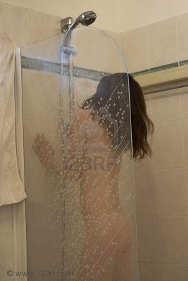

Sometimes when I have

my period I will

feel a pain in my tummy.

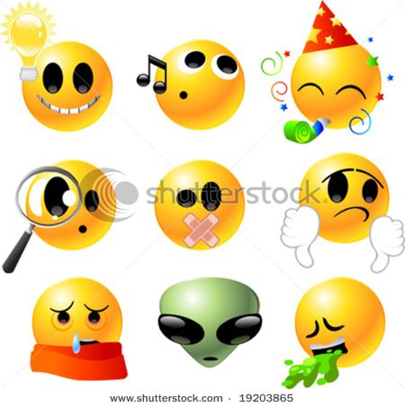

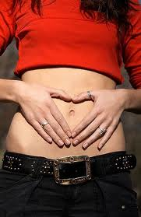

If the pain hurts I will ask for my heated pack.

I will put it on my tummy.

It will help me feel better.

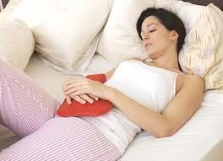 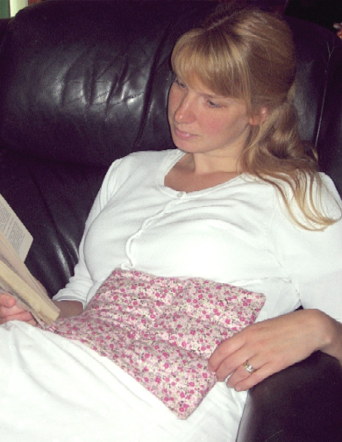

Having my period means I am growing up.